# SIMPLEX – LEAVE MANAGEMENT

1. Manage Employee
   1. Employee List
   2. Manage Employees
2. Roles & Permission (You need to let us know what are the things they can access)
   1. Admin
   2. Accountant
   3. HR Manager
   4. Employee
3. Department Setup
4. Designation setup
5. Holiday List & Working Hours Set up
6. Medical Claims
   1. Allowance & Balance
   2. Claims History
   3. Apply Claim
7. Attendance Management:
   1. View Attendance & History (By default it is present for all employees, but if they took leave then it will be visible in their attendance records )
8. Leave Management:
   1. Leave Types
   2. Apply Leave
   3. Leave Record
   4. Leave Rules
9. Employee Department Calendar
10. Notice Board
11. Notifications on dashboard
12. Email Notification Settings ;
    1. Leave
       1. Apply notification only to the employee (not to approver)
       2. Approved/rejected notification only to employee.
       3. Pending Notification (1 day before) to Approver & admin & employee
    2. Probation period end;
       1. Notification to employee and HR Manager
13. Documents Folder Access
14. Settings

ADMIN PORTAL

## Dashboard ;

* 1. Employee need not to mark the Attendance, it will always be automatically marked as present as long as they don’t took/apply for any leave. So all days (Except Holidays, weekends, leave days) system will mark them present.
  2. Will see the below things on Dashboard;
     1. Total Present Employees (Day/Week/Month/Year)
     2. Total Absent Employees -Based on leaves (Day/Week/Month/Year)
     3. Total Half Day Employees (Day/Week/Month/Year)
     4. Total Leave Applications (Day/Week/Month/Year)
     5. Total Medical Claims Applications (Day/Week/Month/Year)
     6. Attendance Calendar (Based on leaves, by default everyone is present except on leave days, holidays and weekends)
     7. Notice Board
     8. Notifications
     9. Birthday Alerts (Without Year)
     10. Probation Period Alert
  3. So, the structure of the Dashboard will be something like below ;

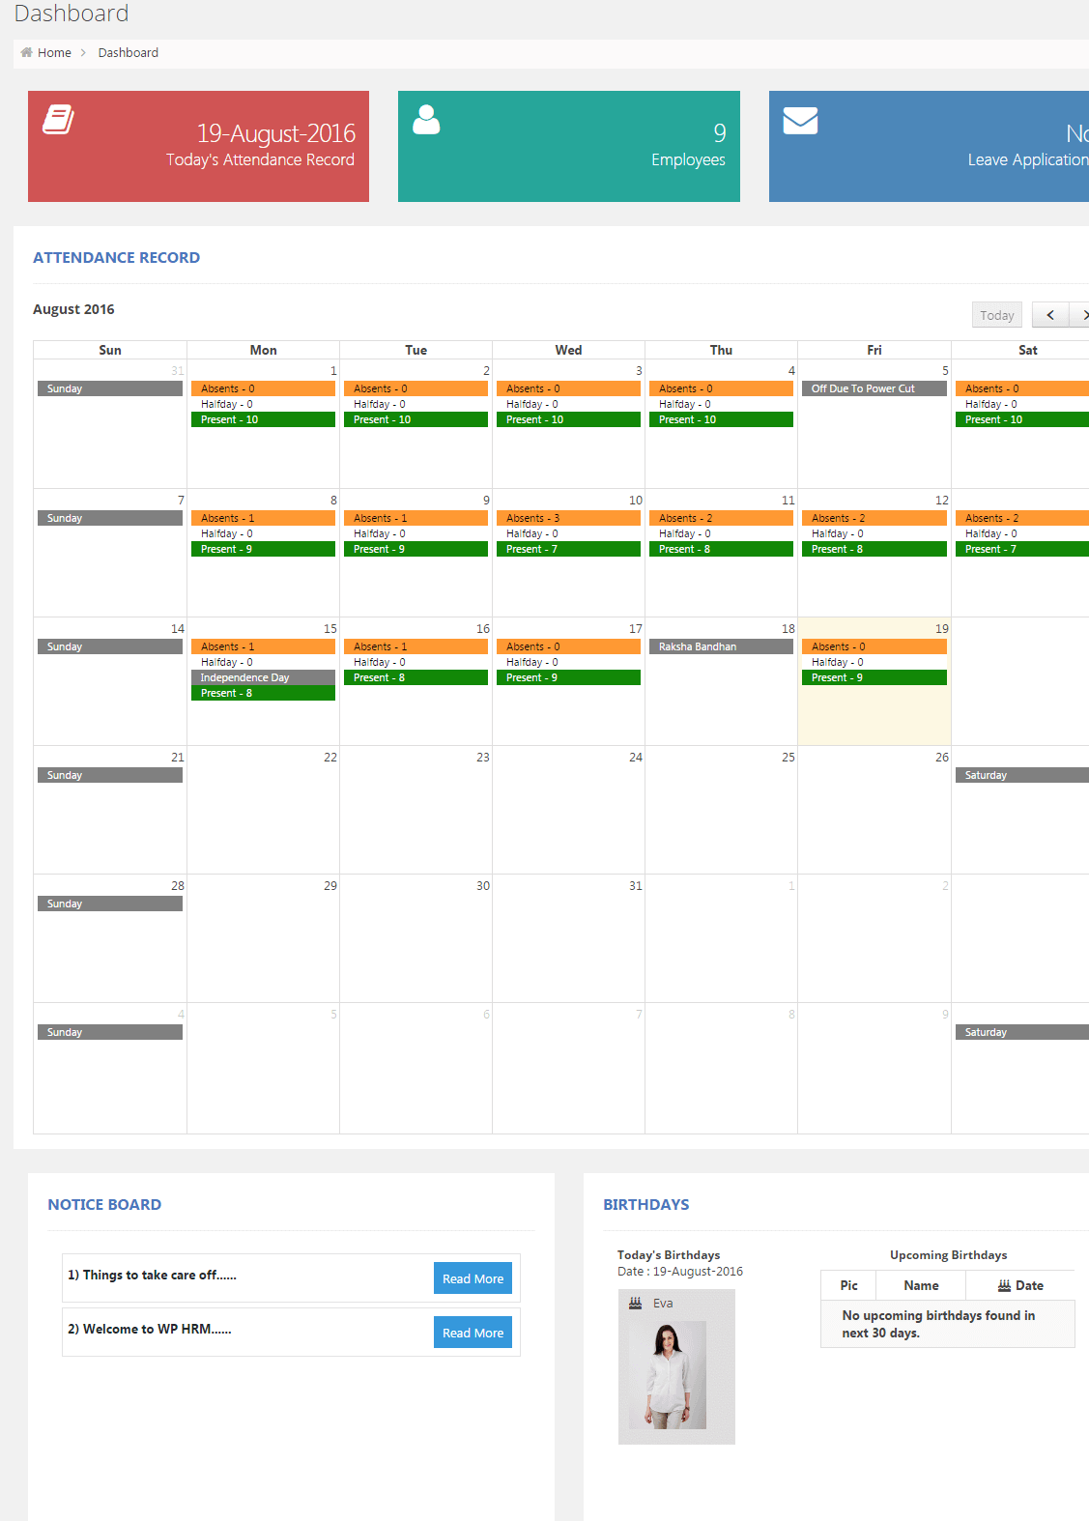

## Employee

* 1. Add Employees ;
     1. Can add the employee details and fields will be decided before starting the coding/programing
     2. We have already mentioned the fields in requirement doc which we sent to you, please confirm.
     3. So, the structure of the Add Employee will be something like below ;

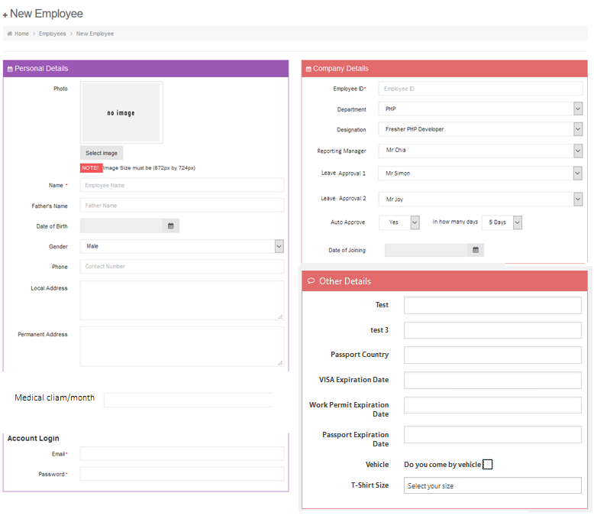

* 1. List of All employees .
     1. Can see the List of all the employees.
     2. Can add/edit/delete/inactive and export the List of employees.
     3. Fields visible on this page and can filter or sort based on those ;
        1. S.No
        2. Employee Id
        3. Name (First Name + Last Name)
        4. Department
        5. Handphone Number
        6. Date of Joining
        7. Status
     4. Structure will be something like shown below;

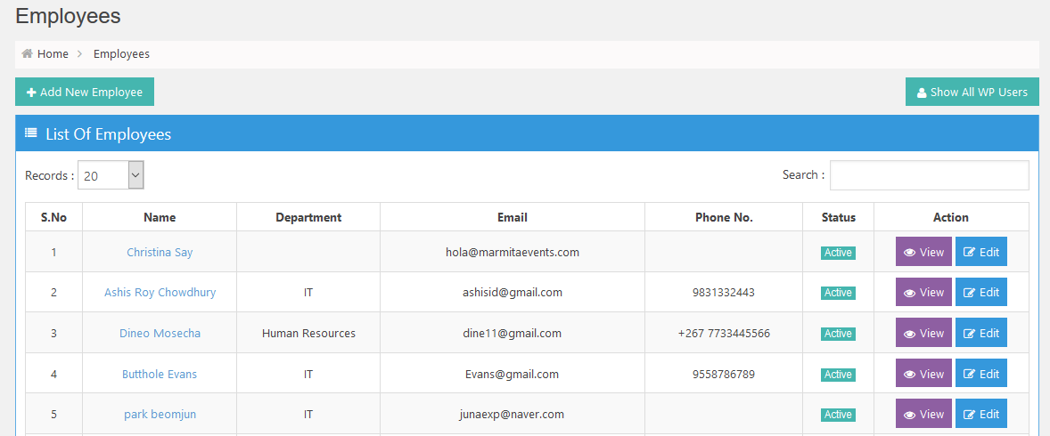

## Department & Designation

* + 1. Can see the List of all the Departments & Designations.
    2. Can add/edit/delete and export.
    3. Fields visible on this page;
       1. S.No
       2. Department Name
       3. Designation
       4. Action
    4. Structure will be something like shown below;

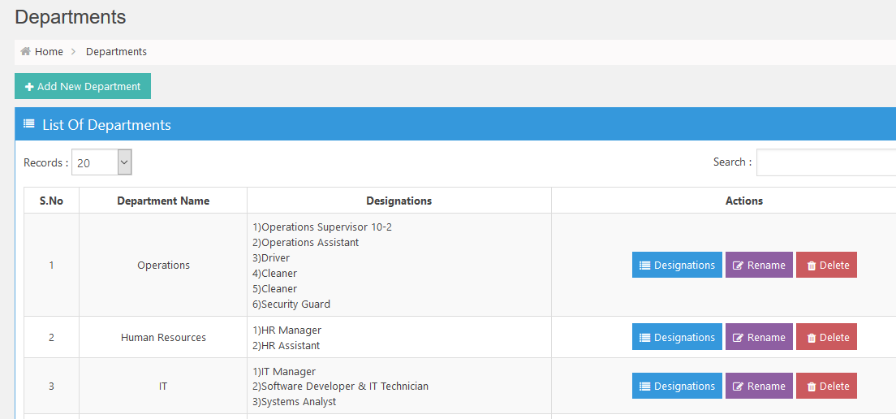

## Holiday List

* + 1. Can see the List of all Holidays and Off days.
    2. Can add/edit/delete and export.
    3. Fields visible on this page;
       1. Left Side : Months
       2. Right Side : List of Holidays or Off days
    4. Need to update the Holidays & offdays every year
    5. Structure will be something like shown below;

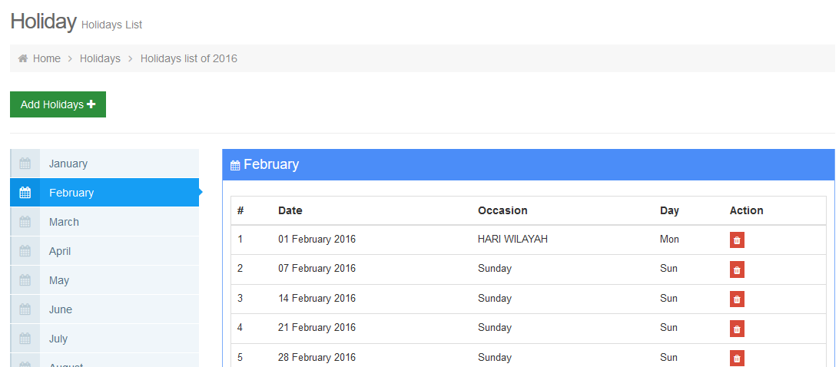

## Attendance Records

* + 1. Can see the List of all the Employee with their leave/attendance records.
    2. Can add/edit/delete and export.
    3. Fields visible on this page;
       1. S.No
       2. Employee id
       3. Name
       4. Picture of Employee
       5. Last Absent Date (Based on the leave)
       6. Leaves Summary
       7. View Detail Button
    4. Structure will be something like shown below;

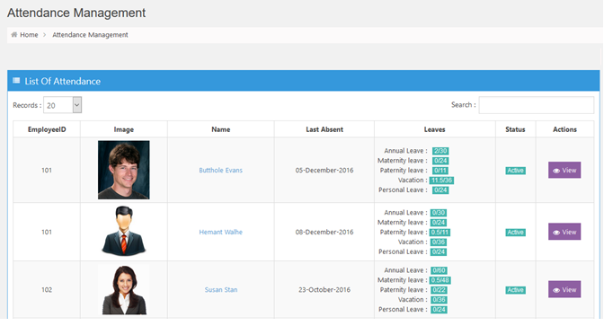

1. Once you click on View More Button then it will show then it will show the leave/attendance records.
2. Employee need not to mark the Attendance, it will always be automatically marked as present as long as they don’t took/apply for any leave. So all days (Except Holidays, weekends, leave days) system will mark them present.
3. On the Attendance Calendar, by default everyone is present except on leave days, holidays and weekends)
4. Can add/edit/delete and export.
5. Structure will be something like shown below;

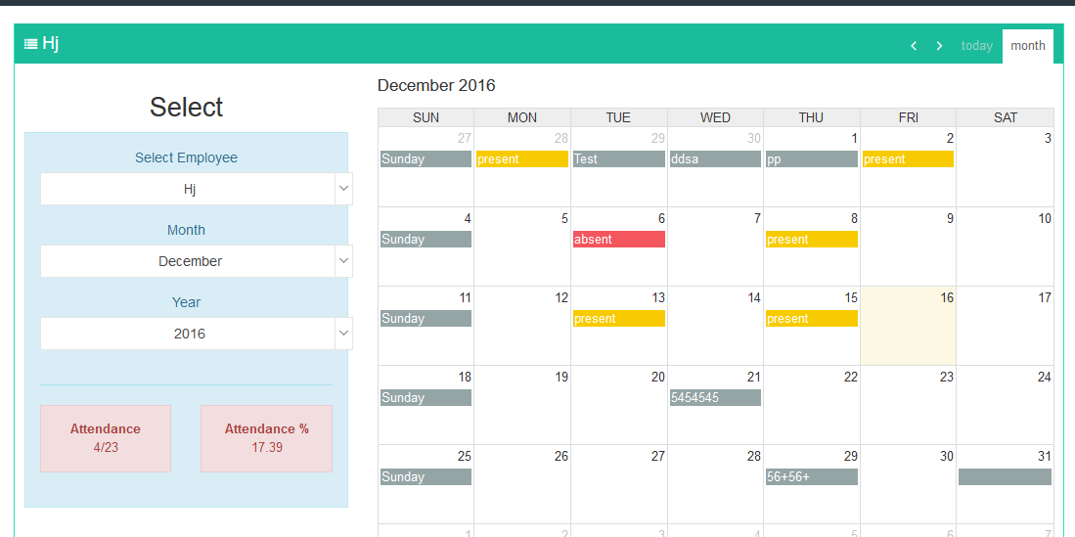

## Leaves

* + 1. Can see the List of all the Leaves applied by the employees
    2. can add/edit/delete and export.
    3. Fields visible on this page;
       1. S.No
       2. Employee id
       3. Name
       4. Leave Type
       5. Reason
       6. Approver name
       7. Comment
       8. Leave Dates (ex 11 Dec 16 to 20 Dec 16)
       9. Date Applied On
       10. Date Approved on
       11. Status
       12. Action Buttons (View/Edit/ Delete)
    4. Structure will be something like shown below;

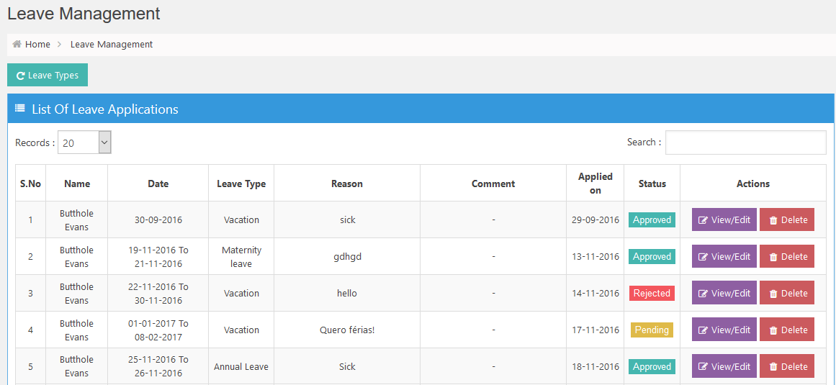

1. Once they click on View/Edit Button then will see the popup with detail.
2. Can Approve/Reject the leave with Comment
3. Structure will be something like shown below;

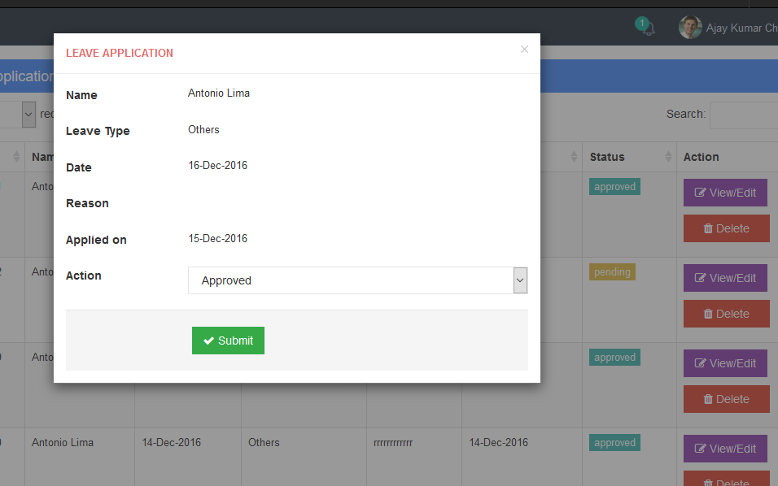

## Leaves Types

* + 1. Can see the List of all the Leaves Types
    2. can add/edit/delete and export.
    3. Fields visible on this page;
       1. S. No
       2. Leave Type
       3. Time Period
       4. No of leave (By Default)
       5. Reason
       6. Action Buttons (View/Edit/Delete)
    4. Structure will be something like shown below;

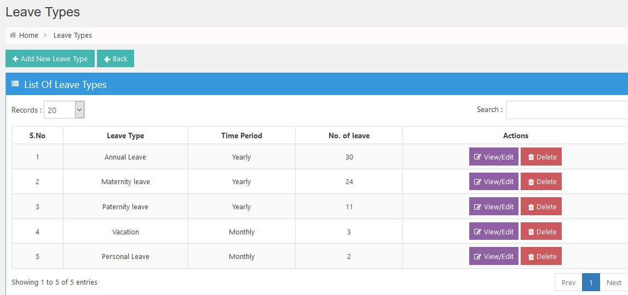

## Medical Claims ;

* + 1. Can see the List of all Medical Claims
    2. can add/edit/delete and export.
    3. Fields visible on this page;
       1. S. No
       2. Employee Id
       3. Employee Name
       4. Description of Claim
       5. Amount Claim
       6. Remaining Amount
       7. Date Applied
       8. Date Approved
       9. Approver Name
       10. Action Buttons (View/Edit/Delete)
    4. Structure will be something like shown below;

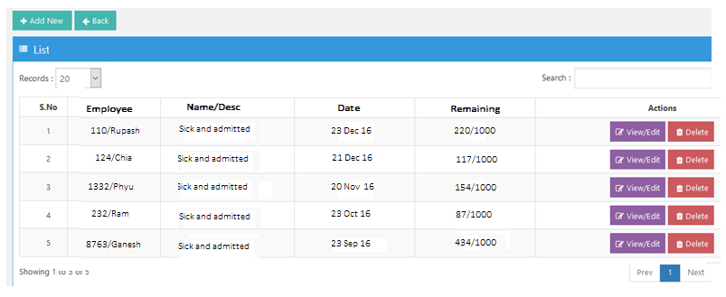

## Notices ;

* + 1. Can see the List of all Notices
    2. can add/edit/delete and export.
    3. Fields visible on this page;
       1. S. No
       2. Notice title
       3. Description
       4. Date
       5. Action Buttons (View/Edit/Delete)
    4. Structure will be something like shown below;

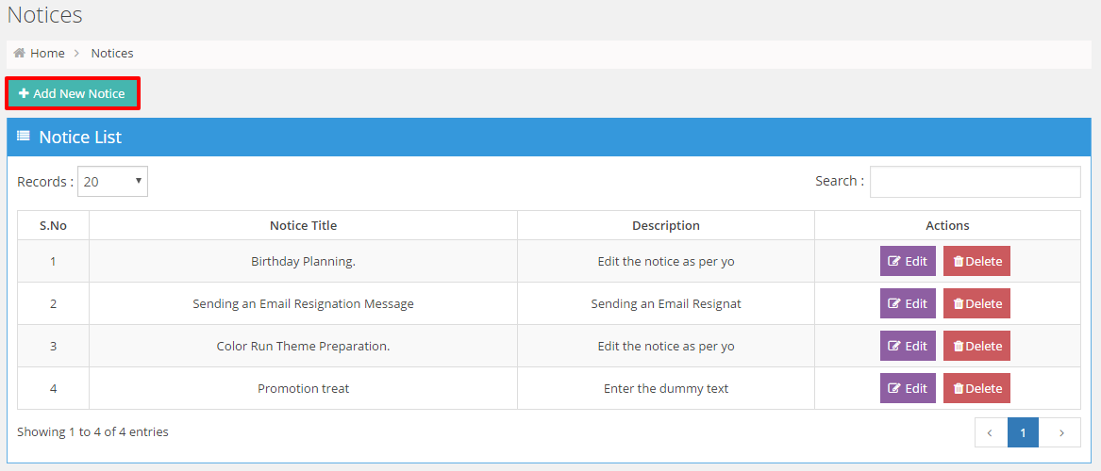

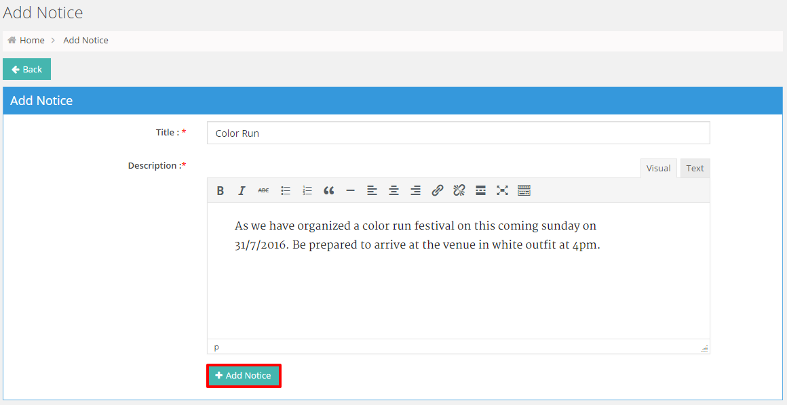

## Notification ;

* + 1. Can see the List of all Notifications like
       1. Leaves applications
       2. Approved leaves notification
       3. Medical Claim Application
       4. Approved Medical Claims
       5. Probation Period Notification
       6. Department Meeting Calendar Notification
    2. can add/edit/delete/mark them read/unread .
    3. Fields visible on this page;
       1. S. No
       2. Message Type
       3. Description
       4. Date
       5. Status
       6. Action Buttons (View/Delete)
    4. Structure will be something like shown below;

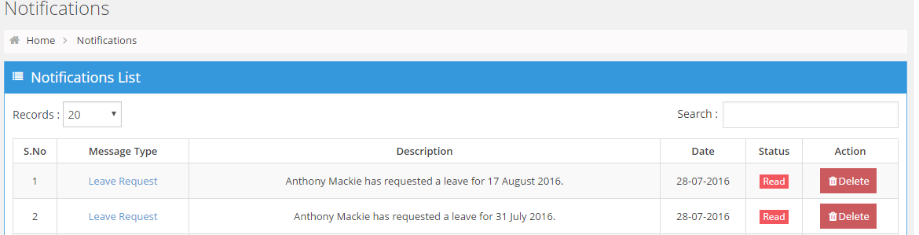

## Meeting Out Calendar (Only For Sales and Marketing Department) ;

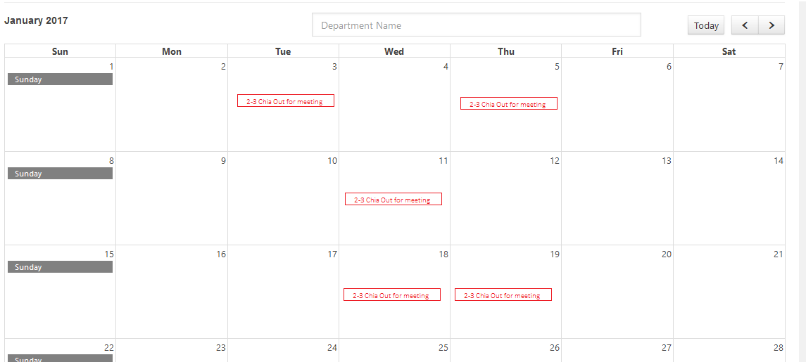

* + 1. Can see all the meetings of both the Departments (SALES and Marketing ) .
    2. Add/Edit/Delate
    3. Filter based on the department (Sales or Marketing)
    4. Click on the particular meeting to see the detail of that meeting.
    5. Department can see only his meetings. example: sales can see all the meetings on his sales department only. Marketing can see the meetings of marketing department only .

## Document Folder ;

* + 1. Can see the List of all Folders
    2. Can add/edit/delete/view the folders.
    3. Assign the permissions to the user to view these folders.
    4. Folders will consist of the Files(PDF, Excel, word) which employee can download.
    5. Structure will be something like shown below;

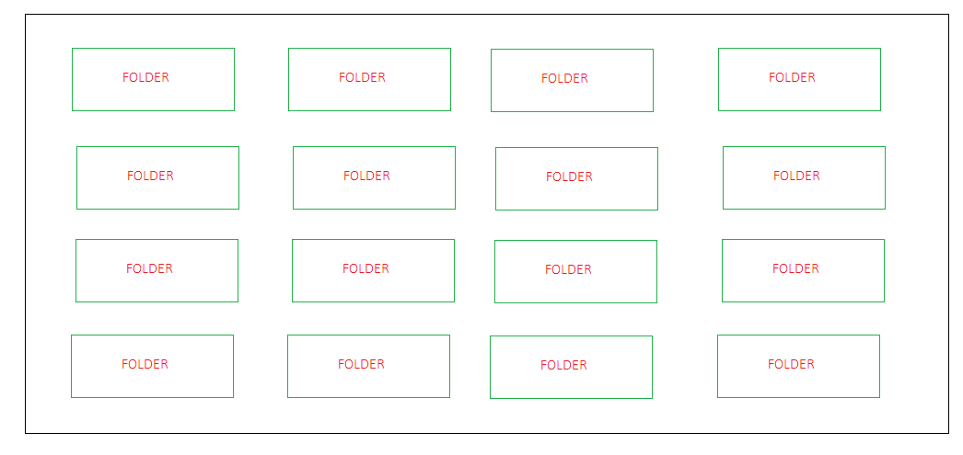

EMPLOYEE PORTAL

## Dashboard;

* 1. Employee need not to mark the Attendance, it will always be marked as present as long as they took/apply for any leave. So all days (Except Holidays, weekends, leave days) system will mark them present.
  2. Will see the below things on Dashboard;
     1. Form Fields are already mentioned in requirement doc sent to you.
     2. Personal Details – few things he can’t change (can view only) which we have mentioned in the doc requirement doc sent to you.
     3. Company Details – few things he can’t change (can view only) which we have mentioned in the doc requirement doc sent to you.
     4. Account Details – few things he can’t change (can view only) which we have mentioned in the doc requirement doc sent to you.
     5. Other Details – few things he can’t change (can view only) which we have mentioned in the doc requirement doc sent to you.
     6. Total Attendance this year
     7. Total Leave this year
     8. Total Medical Claims this year
     9. Attendance Calendar (Based on leaves, by default everyone is present except on leave days, holidays and weekends)
     10. Notice Board
     11. Upcoming Holidays
     12. Notifications
     13. Birthday Alerts (Without Year) – only see his department bdays .
     14. Leave Applications (only for Approvers/ Reporting Manager)
  3. So, the structure of the Dashboard will be something like below ;

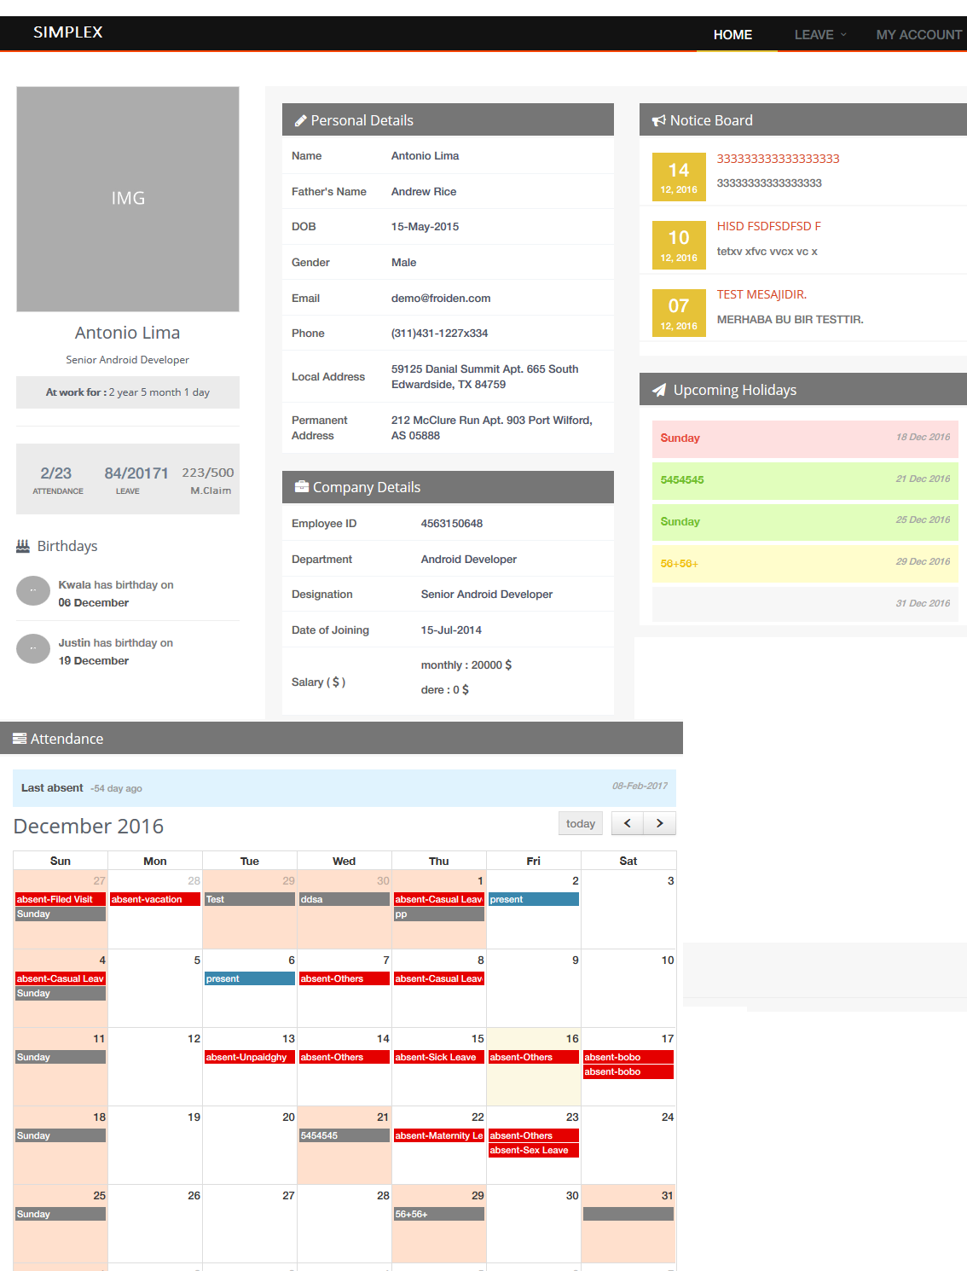

## If Portal is opened by Approver 1 or Approver 2, then he will also see the List of **Employees Leave** which they need to approve.

## My Profile;

All the fields are already mentioned in requirement doc sent to you, please confirm those fields.



## Attendance;

1. Employee need not to mark the Attendance, it will always be automatically marked as present as long as they don’t took/apply for any leave. So all days (Except Holidays, weekends, leave days) system will mark them present.
2. On the Attendance Calendar, by default they will be marked as present except on leave days, holidays and weekends)
3. Can see the leaves/attendance and can export them.
4. Structure will be something like shown below;

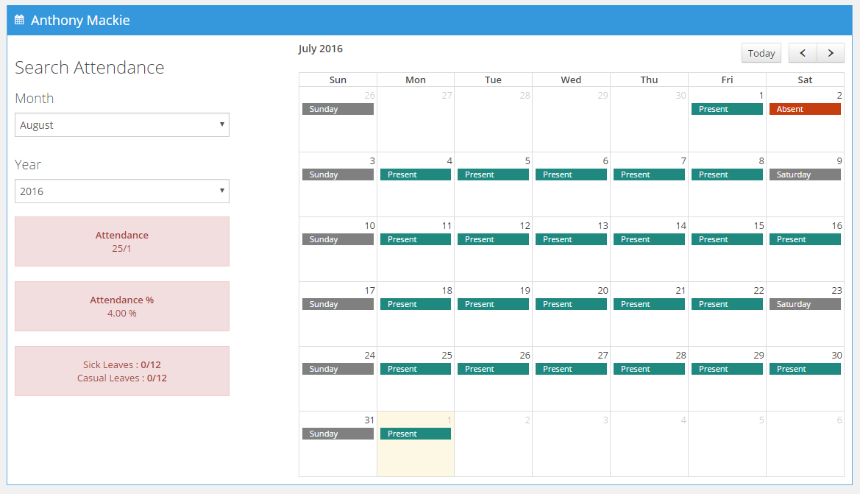

## Leave ;

* + 1. Can see the List of all the Leaves applied by him.
    2. can add/edit/delete the pending leaves only. can’t delete the approved/rejected leaves.
    3. Fields visible on this page;
       1. S.No
       2. Leave Type
       3. Reason
       4. Approver name
       5. Comment
       6. Leave Dates (ex 11 Dec 16 to 20 Dec 16)
       7. Date Applied On
       8. Date Approved on
       9. Status
       10. Action Buttons (View/Edit/ Delete)
    4. Structure will be something like shown below;

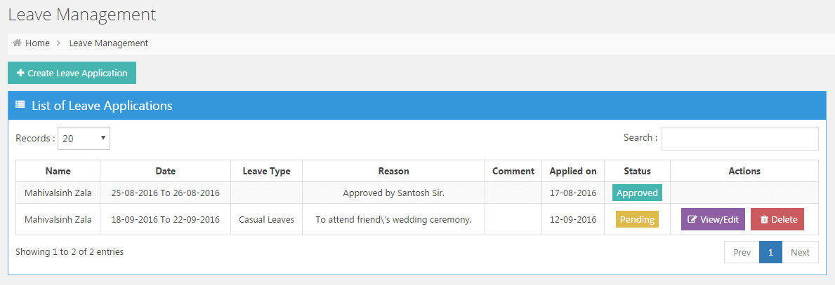

1. Once they click on View/Edit OR CREATE LEAVE Application Button then will see the popup with detail.
2. He can create the leave/edit application.
3. Below are the fields ;
   1. Leave Type
   2. From Dates (with half day of AM/PM )
   3. To Dates (with half day of AM/PM )
   4. Reason of Leave
4. Structure will be something like shown below;

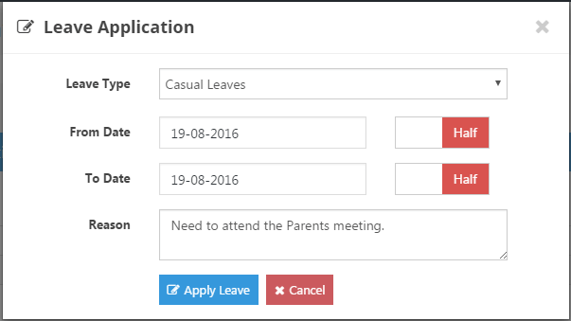

## Medical Claims

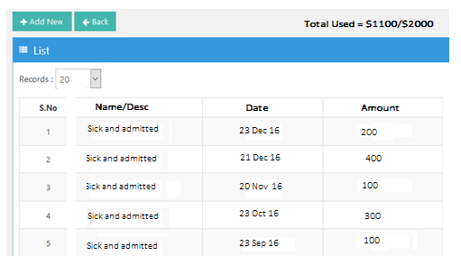

1. Can see the List of all of his Medical Claims
2. can add/edit/delete the Pending Claims only (not approved claims) and can export them.
3. Fields visible on this page;
   * + 1. S. No
       2. Description of Claim
       3. Amount Claim
       4. Remaining Amount
       5. Date Applied
       6. Date Approved
       7. Approver Name
       8. Action Buttons (View/Edit/Delete) – delete and edit only for pending claims.

## Notices ;

* + 1. Can see the List of all Notices
    2. can view and export them.
    3. Fields visible on this page;
       1. S. No
       2. Notice title
       3. Description
       4. Date
       5. View detail
    4. Structure will be something like shown below;

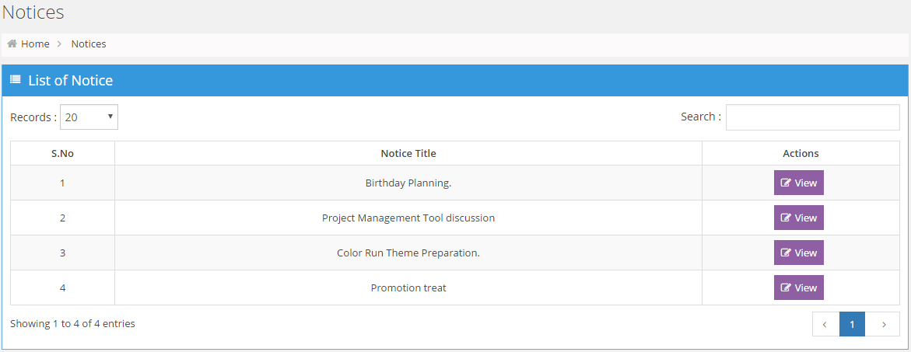

## Notification ;

* + 1. Can see the List of all Notifications like
       1. Leaves applications
       2. Approved leaves notification
       3. Medical Claim Application
       4. Approved Medical Claims
       5. Probation Period Notification
       6. Department Meeting Calendar Notification (only for Sales and Marketing )
    2. can mark them read/unread .
    3. Fields visible on this page;
       1. S. No
       2. Message Type
       3. Description
       4. Date
       5. Status
    4. Structure will be something like shown below;

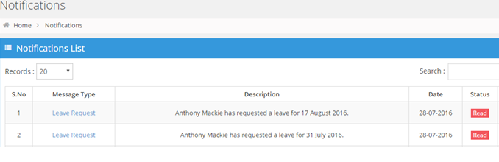

## Meeting Out Calendar (Only for Sales and Marketing Department) ;

* + 1. Can see all the meetings of their own the Departments (only for SALES and Marketing ) .
    2. Can add the meetings.
    3. Click on the particular meeting to see the detail of that meeting.
    4. Department can see only his meetings. example: sales can see all the meetings on his sales department only. Marketing can see the meetings of marketing department only .



## Documents ;

* + 1. Can see the List of all Folders which is assigned to him by Admin.
    2. Folders will consist of the Files(PDF, Excel, word) which he can download.
    3. Structure will be something like shown below;

